**Lab 4:** Kirchhoff’s Laws and DC Analysis

**Objective:**

To apply Kirchoff’s Laws to the analysis of a simple resistive circuit and experimentally verify the laws.

**Equipment and Components:**

1. DC Power Supply
2. Digital Multimeter
3. Resistors: 5.1 kΩ, 13 kΩ, 20 kΩ, 24 kΩ, 43 kΩ, 56 kΩ, 120 kΩ
4. Multisim file from Lab 1.

Note: *You may need to use combinations of up to two resisters to create some of the needed values, i.e. for a 20 kΩ use 2 - 10 kΩ in series. Do not worry about getting exact values. Take advantage of the resisters tolerances.*

**Preliminary:**

Using the circuit shown in Figure 4.1, prepare the following calculations.

1. Using resistor series/parallel/Δ-Y combinations, determine the equivalent resistance seen by the 9 V source as well as the current and power provide to the circuit from the source.
2. Using node analysis, calculate the voltage drop (Vx) across the 56 kΩ resistor.
3. Using mesh analysis, calculate currents I1 and I2.
4. Using the node voltages and/or the mesh currents, calculate the power dissipated in each resistor and total power dissipated by the circuit. Does this match the power provided by the source, found in preliminary part 1. Will 1/8 W resistors work for the construction of the circuit?
5. Compare the calculated voltages and currents to the simulated values from Lab 1. How do they compare?

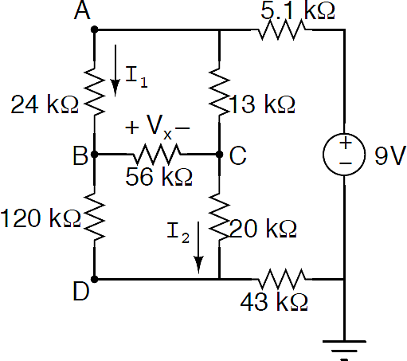

Figure 4.1: Circuit to be analyzed

**Procedure:**

Build the circuit shown in Figure 4.1 and perform the following experiments:

1. Remove the power supply and measure the equivalent resistance seen by the power supply with an ohmmeter. Compare the measured value to the calculate value in the preliminary and explain any discrepancy.
2. Reconnect the power supply and measure the same equivalent resistance as done in part 1. Explain the reason behind any discrepancy. *Hint: How does an Ohm meter work?*
3. With the power supply still connected measure the following voltages:
   1. Measure Vx and compare it to the calculated value in the preliminary part 2.
   2. Measure the voltages for each element in the KVL loop in Figure 3.1 and verify that Kirchhoff’s Voltage Law remains valid. Pay close attention to the polarity of the voltmeter while making these measurements and calculations.
   3. Verify that KVL is valid for another randomly chosen path.
4. Measure the following currents:
   1. Measure I1 and I2 and compare them to the calculated values in the preliminary part 3.
   2. Measure all currents flowing through the elements connected to node B and verify that Kirchhoff’s Current Law remains valid. Pay close attention to the polarity of the ammeter while making these measurements and calculations.
   3. Verify that KCL is valid for another randomly chosen node.
5. Have the instructor verify proper operations of the circuit. Perform at least one voltage measurement and one current measurement of their asking.
6. Measure the current and voltage and calculate the power provided by the 9V power supply. Does this match with the calculated total power dissipated in the preliminary?

**Conclusion:**

Discuss your findings in a ½+ page write up. Summarize your findings in a table containing the **simulation result**, **preliminary calculation** and **measured value**. Calculate % errors between the measured vs calculated values.

Explain any similarities and discrepancies in these numbers as well as any other measurements conducted during the lab (see procedure parts 1, 2, and 6).